**8 SCIENCE 2015**

### GEOLOGY TEST ONE

Name: ____________________ Teacher: ___________________ Mark: /50

**Percentage: %**

**SECTION A: MULTIPLE CHOICE (15 marks)**

**Select the most correct answer for each question below.**

**Please answer on the multiple choice answer grid below.**

1. A B C D 10. A B C D

2. A B C D 11. A B C D

3. A B C D 12. A B C D

4. A B C D 13. A B C D

5. A B C D 14. A B C D

6. A B C D 15. A B C D

7. A B C D

8. A B C D

9. A B C D

**1.** The study of rocks, their history and the processes that form and change them is known as:

(a) geography.

(b) geology.

(c) geophysics

(d) geomorphics.

**3.** The first type of rocks to form and were the start of the Earth’s crust are:

(a) igneous rocks.

(b) metamorphic rocks.

(c) sedimentary rocks.

(d) core rocks.

**3.** Rocks are made up of chemical substances called:

(a) gainlets.

(b) crystals.

(c) fragments.

(d) minerals.

The diagram on the right shows the composition of soil. Question 4-6 refers to this diagram.

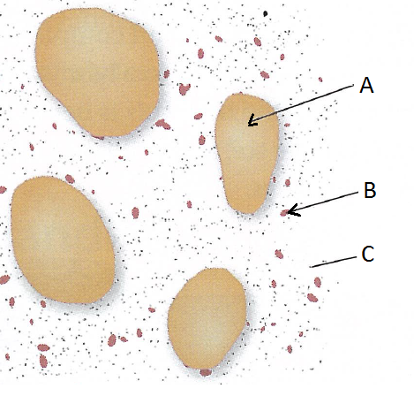**4.** Label ‘A’ refers to:

(a) silt.

(b) nucleus.

(c) a sand grain.

(d) clay.

**5.** Label ‘B’ refers to:

(a) silt.

(b) a sand grain.

(c) nucleus.

(d) clay.

**6.** Label ‘C’ refers to:

(a) nucleus.

(b) clay.

(c) silt.

(d) a sand grain.

**7.** Choose the correct definition for ‘permeability’.

(a) The amount of empty space in the rock.

(b) The amount of occupied space in the rock.

(c) A measure of how fast water enters the soil.

(d) A measure of how fast soil flows.

**8.** Choose the correct definition for ‘consistency’.

(a) The tendency of soil particles to clump together.

(b) The breakdown of soil by constant layering.

(c) The cycle that soil undergoes in changing form.

(d) The amount of living matter in the soil.

**9.** The rock on the right is light coloured, floats in water and has many holes, it is:

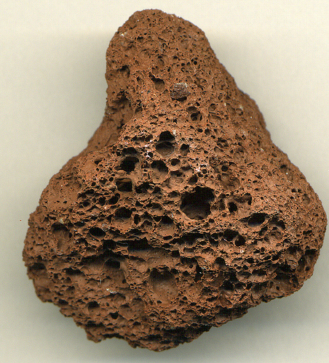

(a) dead.

(b) scoria.

(c) moon rock.

(d) pumice.

**10.** Select the **incorrect** statement below.

(a) Some gases make rock change to form different chemicals.

(b) The colour of rock can change due to chemical weathering.

(c) Rock is made stronger when gases react with it.

(d) Oxygen and carbon dioxide in the air can react with certain types of rocks.

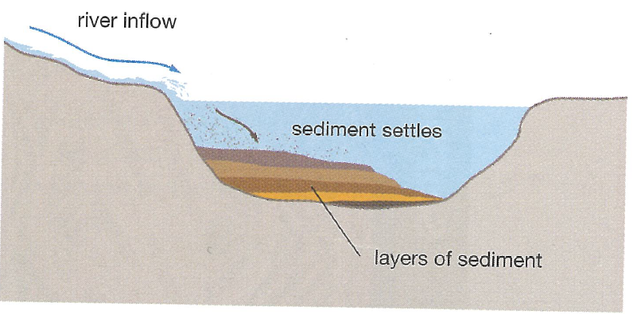

**11.** The diagram on the right shows the process known as:

(a) weathering.

(b) sedimentation.

(c) deposition.

(d) both b and c.

**12.** Three agents of erosion are:

(a) water, ice, fire.

(b) fire, wind, ice.

(c) water, wind, ice.

(d) fire, water, wind.

**The diagram on the right shows a clump of soil. Questions 13-25 refer to the diagram.**

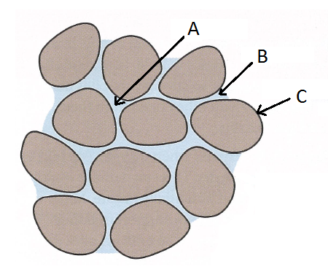**13.** Label ‘A’ refers to:

(a) the water film.

(b) a soil crumb.

(c) a pore space.

(d) permeability space.

**14.** Label ‘B’ refers to:

(a) permeability space.

(b) a soil crumb.

(c) the water film.

(d) a pore space.

**15.** Label ‘C’ refers to:

(a) the water film.

(b) permeability space.

(c) a pore space.

(d) a soil crumb.

**SECTION B: SHORT ANSWER (35 marks)**

**1a.** Name the hot molten rock that pours out of volcanoes. (1 mark)

_____________________________________________________________________________________

**b.** Name the hot molten rock that has not reached the Earth’s surface. (1 mark)

_____________________________________________________________________________________

**2.** Circle the correct characteristic of igneous rocks from each pair below. (1 mark)

**a)** Hard / soft  **b)** Weak / strong

**3.** Explain the difference between extrusive igneous rocks and intrusive igneous rocks. (2 marks)

_____________________________________________________________________________________

_____________________________________________________________________________________

_____________________________________________________________________________________

_____________________________________________________________________________________

_____________________________________________________________________________________

**4.** Label the diagram of the Earth’s structure below. (3 marks)

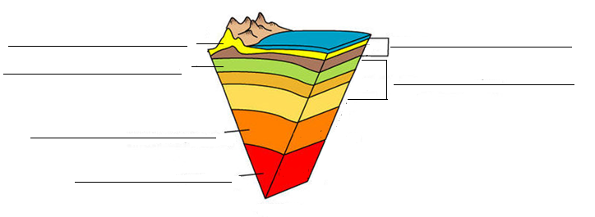

**5a.** Name two igneous rocks that are intrusive. (1 mark)

_____________________________________________________________________________________

**b.** Name two igneous rocks that are extrusive. (1 mark)

_____________________________________________________________________________________

**6.** Write a definition for ‘interlocking crystals’. (2 marks)

_____________________________________________________________________________________

_____________________________________________________________________________________

_____________________________________________________________________________________

_____________________________________________________________________________________

**7.** Label the diagram of the volcano below. (3 marks)

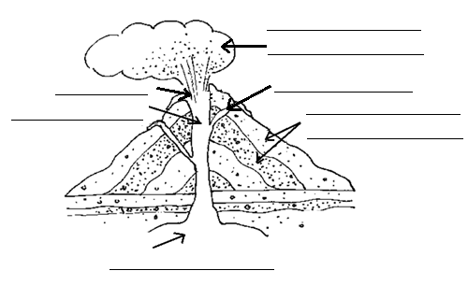

**8.** A geologist removed some rock from the edge of an old lava flow. No crystals could be seen when the rock was studied under a microscope. The rock was a dark colour and it was hard, but very brittle. It was easily broken into pieces by hitting it, and broke into very sharp, thin strips which were very shiny. Apply your knowledge of rock types and formation to:

**a.** State whether this rock is intrusive or extrusive.  (1 mark)

_____________________________________________________________________________________

**b.** Identify the type of igneous rock it is (name of the rock). (1 mark)

_____________________________________________________________________________________

**c.** Explain why no crystals could be found even though the rock was obviously igneous. (2 marks)

_____________________________________________________________________________________

_____________________________________________________________________________________

_____________________________________________________________________________________

_____________________________________________________________________________________

**9.** Fill in the table using the words below (they can be used more than once). (6 marks)

Colour description: ⬩light coloured ⬩dark coloured ⬩transparent

Texture description: ⬩small crystals ⬩no visible crystals ⬩interlocking crystals ⬩large crystals

⬩fine grains ⬩large grains

⬩has obvious holes

|  |  |  |
| --- | --- | --- |
| **Igneous rock** | **Colour description** | **Texture description** |
| Granite | ⬩ | ⬩  ⬩ |
| Pumice | ⬩ | ⬩  ⬩ |
| Basalt | ⬩ | ⬩  ⬩ |
| Scoria | ⬩ | ⬩  ⬩ |

**10.** Circle either true or false for the following statements. (2 marks)

Pumice is used to clean dead skin off feet. True False

Granite is used as barbeque rocks. True False

Dolerite can be used for road surfaces. True False

Basalt can be used for buildings and floor tiles. True False

**11.** Explain the difference between weathering and erosion. (2 marks)

_____________________________________________________________________________________

_____________________________________________________________________________________

_____________________________________________________________________________________

**12.** Explain why the most common place that erosion occurs is on mountains or hills. (2 marks)

_____________________________________________________________________________________

_____________________________________________________________________________________

_____________________________________________________________________________________

_____________________________________________________________________________________

**13.** List four factors of physical weathering (4 marks)

(physical weathering occurs because of these processes).

____________________________________________________________________________________

____________________________________________________________________________________

____________________________________________________________________________________

____________________________________________________________________________________